ITEMS ACCEPTED FOR RECYCLING  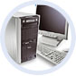 Computers*  Desktops, laptops, servers, LCD monitors, keyboards, mice, speakers, and all other computer components.  Cameras  Camcorders and all non-disposable film and digital cameras.  Office Equipment  Fax machines, typewriters, inkjet cartridges, printers, scanners, routers, shredders, and copiers.  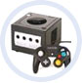  Entertainment Electronics  Car and home audio equipment, satellite and cable boxes, VCRs, DVD players and recorders, headphones, and multimedia projectors.  Multimedia  DVD and VHS movies, audiobooks, and music CDs. All multimedia items must include original covers. | 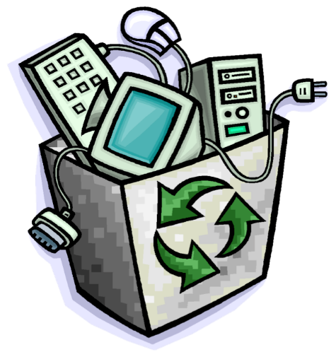  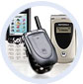  Portable Electronics*  Cell phones, GPS devices, calculators, portable CD and DVD players, PDAs, and MP3 Players.  Video Games  Video games, systems, and accessories.  *Computers and cell phones will be scrubbed before recycling
Items may be in any condition – damaged, non-working, or fully operational.

This fundraiser benefits the Missions supported by the Bold Women of Lovers Lane.
Thank you for your participation!

